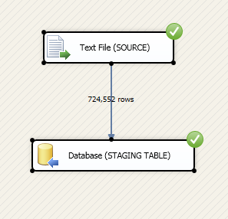

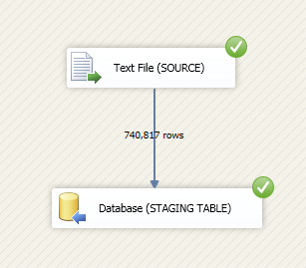

s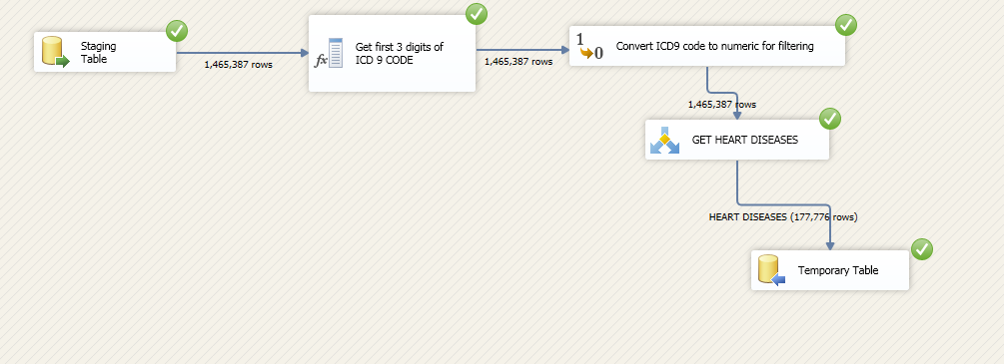

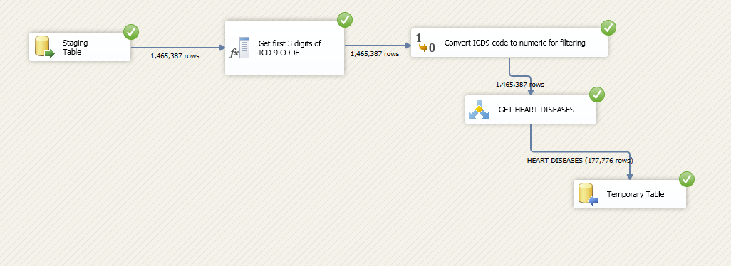

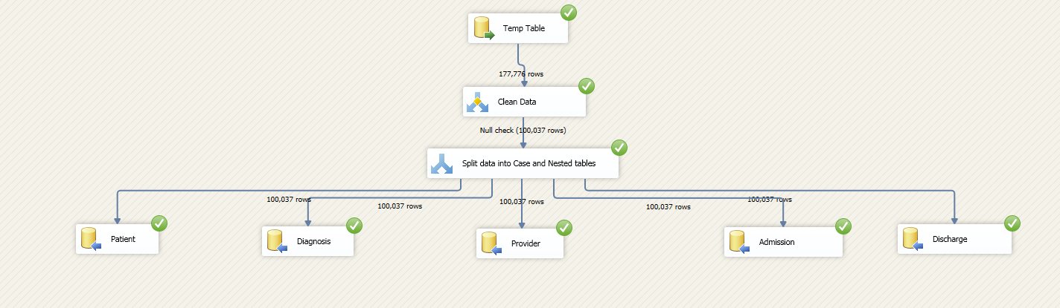



--'RHF'---> Rheumatic fever

--'CRHD' ---> Chronic rheumatic heart disease

-- 'HTD'---> Hypertensive disease

-- 'ISH'---> Ischemic heart disease

-- 'PC' ---> Diseases of pulmonary circulation

-- 'OTH'---> Other forms of heart disease

-- 'CVD'---> Cerebrovascular disease

-- 'AAC'---> Diseases of arteries, arterioles, and capillaries

-- 'VLCS---> Diseases of veins and lymphatics, and other diseases of circulatory system

|  |  |
| --- | --- |
| **NEW_PRINC_DIAG_CODE** | **NUMBER OF CASES** |
| ISH | 33077 |
| OTH | 29583 |
| CVD | 14990 |
| AAC | 9094 |
| HTD | 5721 |
| VLCS | 4861 |
| PC | 2187 |
| CRHD | 498 |
| RHF | 26 |

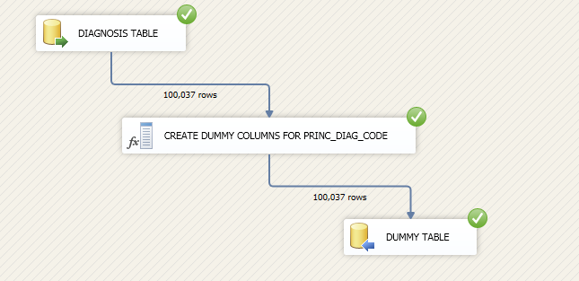

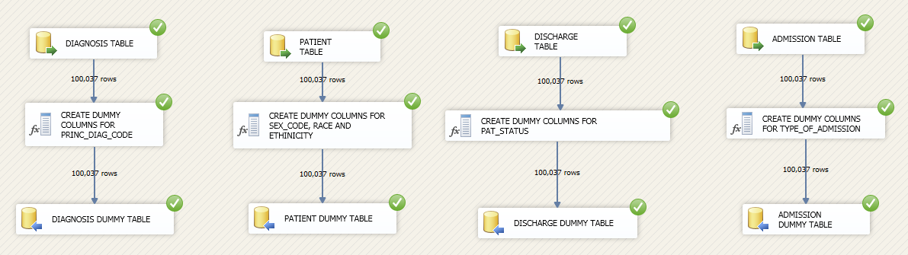

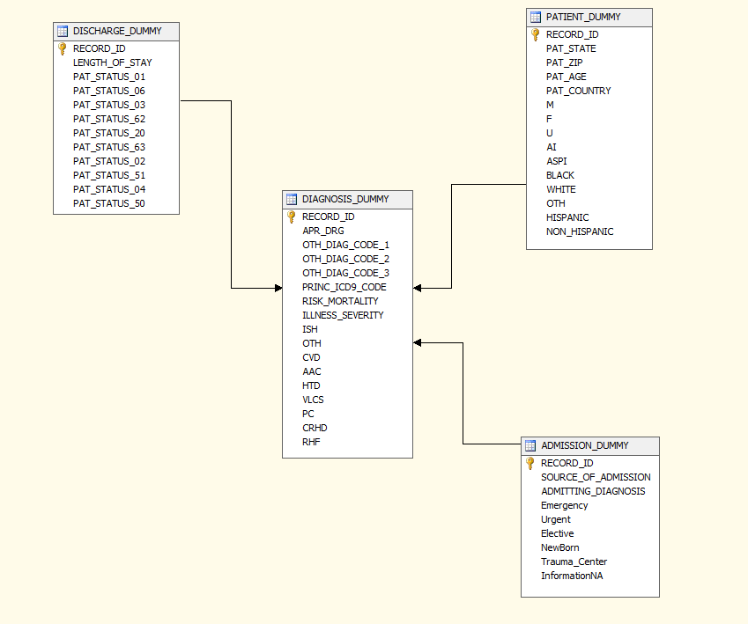

**DATA EXPLORATIONS IN EXCEL FROM DSV**

